### **Name: Nithish Kumar Potlapla**

### **HTML CSS:**

* HTML stands for:
  + **A. HyperText Markup Language**
  + B. High-Level Text Markup Language
  + C. HyperTransfer Markup Language
  + D. HyperLink and Text Markup Language
* Which HTML tag is used for creating an ordered list?
  + A. <ul>
  + **B. <ol>**
  + C. <li>
  + D. <dl>
* In CSS, which property is used to change the text color of an element?
  + A. text-color
  + **B. color**
  + C. font-color
  + D. text-style
* What does the CSS property margin: 10px 20px 15px 5px; represent?
  + **A. Top, Right, Bottom, Left margins**
  + B. Left, Bottom, Right, Top margins
  + C. Top and Bottom margins only
  + D. Left and Right margins only
* Which HTML tag is used for creating a hyperlink?
  + A. <link>
  + **B. <a>**
  + C. <hlink>
  + D. <url>
* The CSS property display: inline-block; is used for:
  + A. Displaying elements as a block
  + **B. Displaying elements inline with a block layout**
  + C. Displaying elements inline with some block-level features
  + D. Hiding elements from the display
* Which HTML tag is used for defining the structure of an HTML document, such as headings and paragraphs?
  + A. <section>
  + **B. <body>**
  + C. <header>
  + D. <main>
* In CSS, the float property is used for:
  + A. Adding floating elements to the page
  + B. Floating text within a paragraph
  + C. Creating rounded corners
  + **D. Positioning an element to the left or right of its containing element**
* Which CSS selector is used to select elements with a specific class?
  + A. #class
  + **B. .class**
  + C. class{}
  + D. classSelector
* What does the HTML attribute alt in the <img> tag represent?
  + **A. Alternative text for the image**
  + B. Alignment of the image
  + C. Altitude of the image
  + D. Animation level of the image

### **HTML MCQs:**

* What is the purpose of the HTML <meta> tag?
  + A. Define a new meta keyword
  + **B. Provide metadata about the HTML document**
  + C. Create a new HTML section
  + D. Define a media element
* Which HTML tag is used for creating a table?
  + **A. <table>**
  + B. <tab>
  + C. <tbl>
  + D. <tr>
* In HTML, which attribute is used to specify the URL of an external stylesheet file?
  + A. src
  + B. link
  + **C. href**
  + D. style
* Which HTML tag is used for creating an unordered list?
  + **A. <ul>**
  + B. <ol>
  + C. <li>
  + D. <dl>
* What is the purpose of the HTML <canvas> element?
  + A. Embed audio content
  + B. Embed video content
  + **C. Draw graphics using JavaScript**
  + D. Define a new font style
* Which HTML tag is used for creating a hyperlink to an email address?
  + A. <email>
  + B. <link>
  + C. <mail>
  + **D. <a>**
* In HTML, which tag is used for creating a line break?
  + A. <lb>
  + **B. <br>**
  + C. <break>
  + D. <line>
* What does the HTML attribute colspan represent in a table cell?
  + **A. Column span**
  + B. Color of the cell
  + C. Content spacing
  + D. Cell padding
* Which HTML tag is used for embedding a video on a webpage?
  + **A. <video>**
  + B. <media>
  + C. <embed>
  + D. <play>
* What does the HTML attribute target="_blank" do in a hyperlink?
  + **A. Opens the link in a new tab or window**
  + B. Links to a blank webpage
  + C. Targets a specific element on the same page
  + D. Ignores the hyperlink

### 

* What is the purpose of the CSS property padding?
  + **A. Adds space inside the element's border**
  + B. Adds space outside the element's border
  + C. Sets the element's font size
  + D. Defines the element's background color
* Which CSS property is used for changing the text alignment within an element?
  + **A. text-align**
  + B. line-align
  + C. content-align
  + D. align-text
* In CSS, what does the property position: absolute; do?
  + A. Positions the element relative to its normal position
  + B. Positions the element relative to its parent
  + C. Removes the element from the document flow

### 

* Which HTML tag is used for creating a hyperlink to another webpage?
  + A. <link>
  + B. <href>
  + **C. <a>**
  + D. <url>
* What does the HTML attribute alt in the <img> tag represent?
  + **A. Alternative text for the image**
  + B. Alignment of the image
  + C. Altitude of the image
  + D. Animation level of the image
* Which HTML tag is used for creating an ordered list?
  + A. <ul>
  + **B. <ol>**
  + C. <li>
  + D. <dl>
* What does the HTML element <article> represent?
  + A. A navigation menu
  + **B. A standalone piece of content that can be distributed and reused**
  + C. A section of a page
* In HTML, the <figcaption> tag is used in conjunction with which other HTML element?
  + **A. <figure>**
  + B. <caption>
  + C. <img>
  + D. <section>
* Which HTML tag is used for creating a form?
  + **A. <form>**
  + B. <input>
  + C. <label>
  + D. <fieldset>
* What is the purpose of the HTML <aside> element?
  + A. Displaying a sidebar
  + B. Defining a section of navigation links
  + **C. Providing additional information or related content**
  + D. Creating a header for a section
* Which HTML attribute is used to define the character encoding for the document?
  + **A. charset**
  + B. encoding
  + C. type
  + D. character
* In HTML, what does the <mark> element represent?
  + **A. A highlighted text**
  + B. A navigation link
  + C. A code block
  + D. A section of emphasized text
* Which HTML tag is used for creating a horizontal line?
  + A. <line>
  + **B. <hr>**
  + C. <hrule>
  + D. <hline>
* In HTML, what does the <summary> element represent?
  + A. A section of code
  + B. A summary of the page
  + C. A navigation link
  + **D. A summary of details in a <details> element**
* Which HTML tag is used for defining the main content of a document?
  + A. <body>
  + **B. <main>**
  + C. <content>
* What is the purpose of the HTML <abbr> element?
  + **A. Creating an abbreviation or acronym**
  + B. Adding bold text
  + C. Aligning text
  + D. Displaying a block of code
* Which HTML tag is used for creating a drop-down list?
  + **A. <select>**
  + B. <list>
  + C. <dropdown>
  + D. <options>
* What is the purpose of the HTML <footer> element?
  + A. Creating a navigation footer
  + B. Defining a page header
  + C. Providing additional information or links related to the content
  + **D. Displaying a copyright notice**

### 

* In CSS, what does the property margin: 10px 20px 15px 5px; represent?
  + **A. Top, Right, Bottom, Left margins**
  + B. Left, Bottom, Right, Top margins
  + C. Top and Bottom margins only
  + D. Left and Right margins only
* Which CSS property is used for changing the background color of an element?
  + A. background
  + B. color
  + **C. background-color**
  + D. bg-color
* In CSS, what does the property position: relative; do?
  + **A. Positions the element relative to its normal position**
  + B. Positions the element relative to its parent
  + C. Removes the element from the document flow
  + D. Aligns the text within an element
* Which CSS property is used for creating rounded corners?
  + A. corner-radius
  + **B. border-radius**
  + C. round-corner
  + D. corner-style
* In CSS, the max-width property is used for:
  + A. Setting the maximum font size
  + **B. Limiting the maximum width of an element**
  + C. Defining the maximum number of lines
  + D. Controlling the maximum height of an element
* Which CSS property is used for changing the font family of text?
  + A. font-style
  + **B. font-family**
  + C. text-font
  + D. font-type
* In CSS, the float property is used for:
  + A. Adding floating elements to the page
  + B. Floating text within a paragraph
  + C. Creating rounded corners
  + **D. Positioning an element to the left or right of its containing element**
* What does the CSS property display: inline-block; do?
  + A. Displays elements as a block
  + **B. Displays elements inline with a block layout**
  + C. Displays elements inline with some block-level features
  + D. Hides elements from the display
* Which CSS property is used for adding a shadow effect to an element's text?
  + A. shadow
  + **B. text-shadow**
  + C. box-shadow
  + D. element-shadow
* In CSS, what does the property box-sizing: border-box; do?
  + A. Adds extra space outside the element's border
  + B. Adds extra space inside the element's border
  + **C. Includes padding and border in the element's total width**
  + D. Excludes padding and border from the element's total width
* Which CSS selector is used to select all elements of a specific type?
  + **A. \***
  + B. #id
  + C. .class
  + D. element
* What is the purpose of the CSS property opacity?
  + A. Controlling the thickness of borders
  + **B. Adjusting the transparency of an element**
  + C. Defining the space between elements
  + D. Changing the color of text
* Which CSS property is used for changing the text color of an element?
  + A. text-color
  + **B. color**
  + C. font-color
  + D. text-style
* In CSS, what does the property text-decoration: underline; do?
  + A. Adds a background color to the text
  + **B. Underlines the text**
  + C. Applies italic style to the text
  + D. Aligns the text
* Which CSS property is used for setting the width of the border of an element?
  + **A. border-width**
  + B. line-width
  + C. width
  + D. border-size

### 

* What is the purpose of the HTML attribute colspan in a table cell?
  + A. Adds space between table columns
  + **B. Sets the column span**
  + C. Defines the color of the cell
  + D. Aligns text within the cell
* In CSS, the z-index property is used for:
  + A. Adding space between elements
  + **B. Specifying the stacking order of elements**
  + C. Creating rounded corners
  + D. Changing the font size
* Which HTML tag is used for creating a definition list?
  + A. <ul>
  + B. <ol>
  + C. <li>
  + **D. <dl>**
* In CSS, what does the property text-align: center; do?
  + A. Aligns text to the left
  + B. Aligns text to the right
  + **C. Centers text horizontally**
  + D. Centers text vertically
* Which HTML tag is used for creating a navigation menu?
  + **A. <nav>**
  + B. <menu>
  + C. <navbar>
  + D. <navigation>
* In CSS, what does the property background-image do?
  + A. Changes the background color of an element
  + **B. Adds a background image to an element**
  + C. Sets the opacity of the background
  + D. Defines the border image of an element
* Which CSS property is used for controlling the space between lines of text?
  + A. line-spacing
  + B. text-line
  + **C. line-height**
  + D. text-spacing

### **Exercise 1:**

HTML:

Create a simple HTML page with the following elements:

* Heading with the text "My First Web Page"
* Paragraph with the text "Welcome to the world of web development."
* <!DOCTYPE html>
* <html>
* <head>
* <title>HTML</title>
* </head>
* <body>
* <h1>My First Web Page</h1>
* <p>Welcome to the world of web development.</p>
* </body>
* </html>

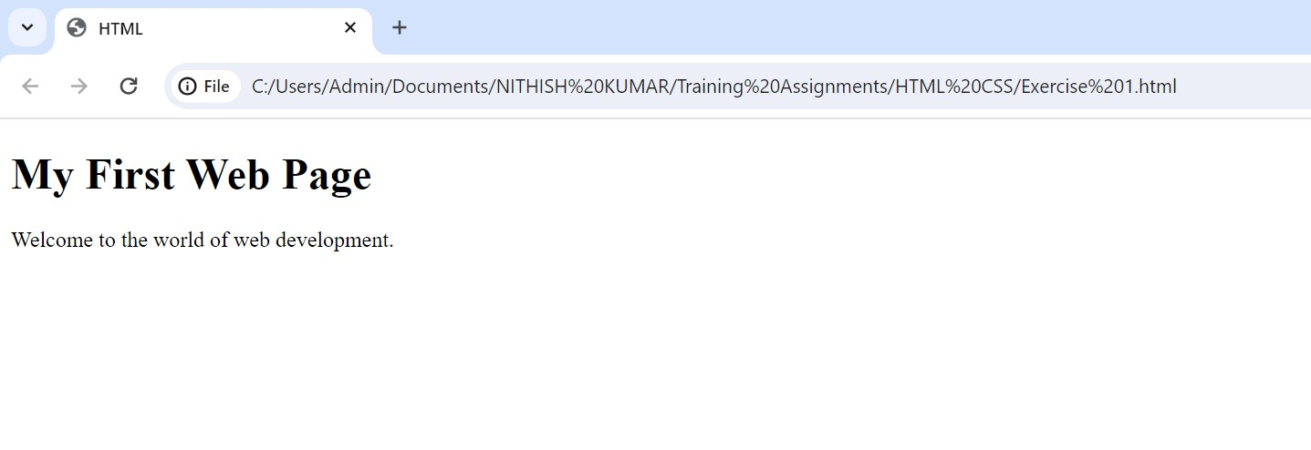

### **Exercise 2:**

HTML:

Create an HTML form with fields for the user's name, email, and a submit button.

CSS:

Style the form to have a centered layout, add some spacing between form elements, and apply different styles to the submit button.

<!DOCTYPE html>

<html>

    <head>

        <title>Form</title>

    </head>

    <body>

        <h1>Form</h1>

        <form style="text-align: center">

        <label for="username">Username:</label>

        <input type="text"><br><br>

        <label for="email">Email:</label>

        <input type="email"><br><br>

        <input type="submit" style="background-color: chartreuse;">

        </form>

    </body>

</html>

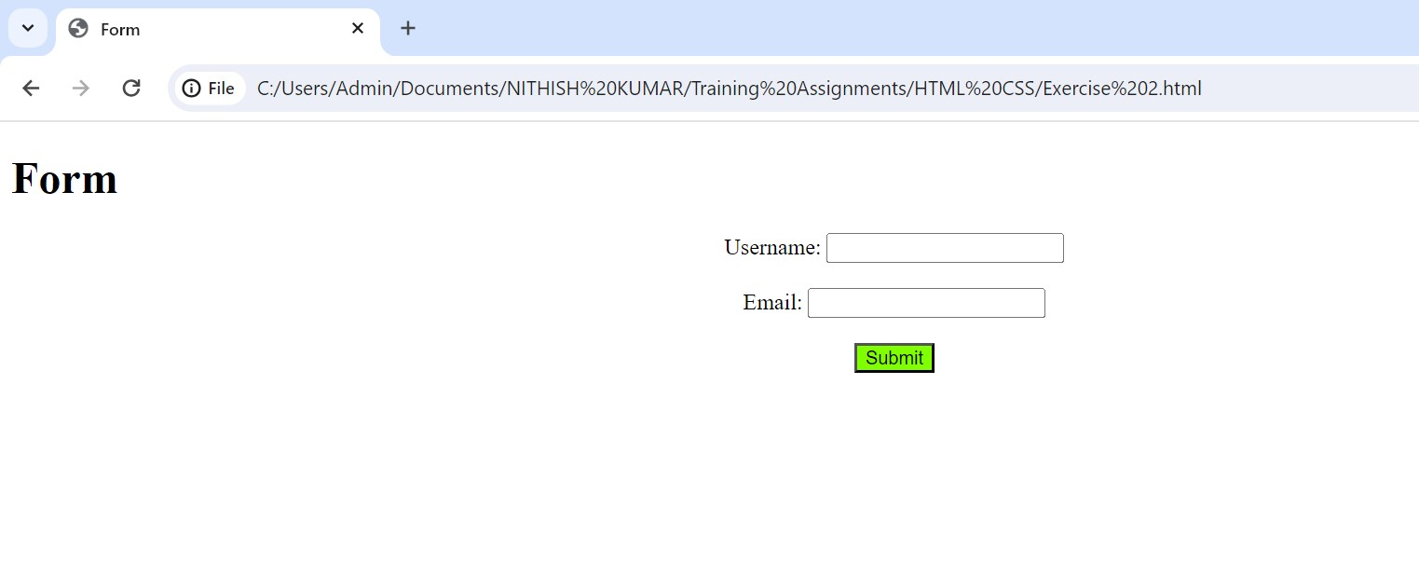

### **Exercise 3:**

HTML:

Create a navigation bar with three links - Home, About, and Contact.

CSS:

Style the navigation bar to have a background color, display the links horizontally, and add some

<!DOCTYPE html>

<html>

    <head>

        <title>Nav</title>

        <style>

            a{

                padding-left: 10px;

            }

        </style>

    </head>

    <body>

        <h1>Navigation</h1>

        <nav style="background-color: aqua;padding: 10px;">

            <a href="">Home</a>

            <a href="">About</a>

            <a href="">Contact</a>

        </nav>

    </body>

</html>

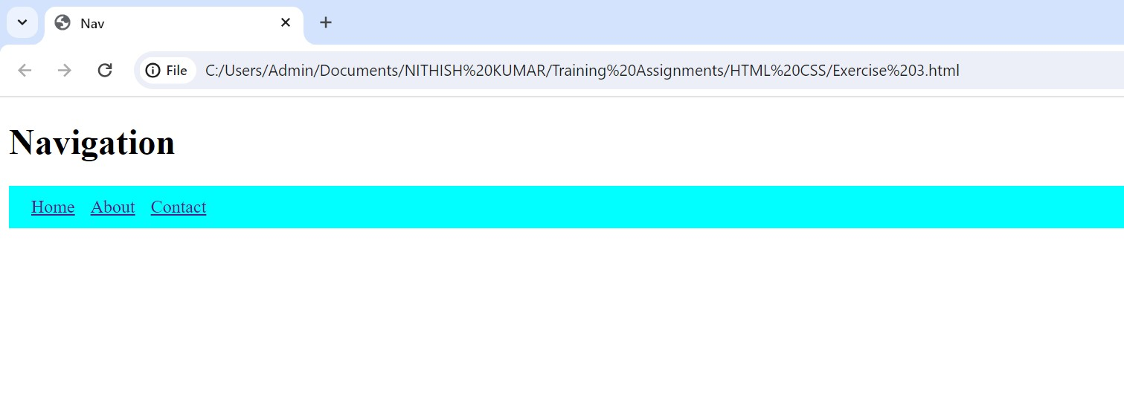

### **Exercise 4:**

HTML:

Create a simple HTML page with an image.

CSS:

Style the image to have a border, rounded corners, and a box shadow.

<!DOCTYPE html>

<html>

    <head>

        <title>Img</title>

        <style>

            .img{

                border: 10px solid;

                border-radius: 20px;

                box-shadow: inset;

            }

        </style>

    </head>

    <body>

        <h1>Image</h1>

            <img class="img" src="https://c.ndtvimg.com/2023-02/bf23r9rg_wildlife_625x300_28_February_23.jpg"

            alt="Elephant">

    </body>

</html>

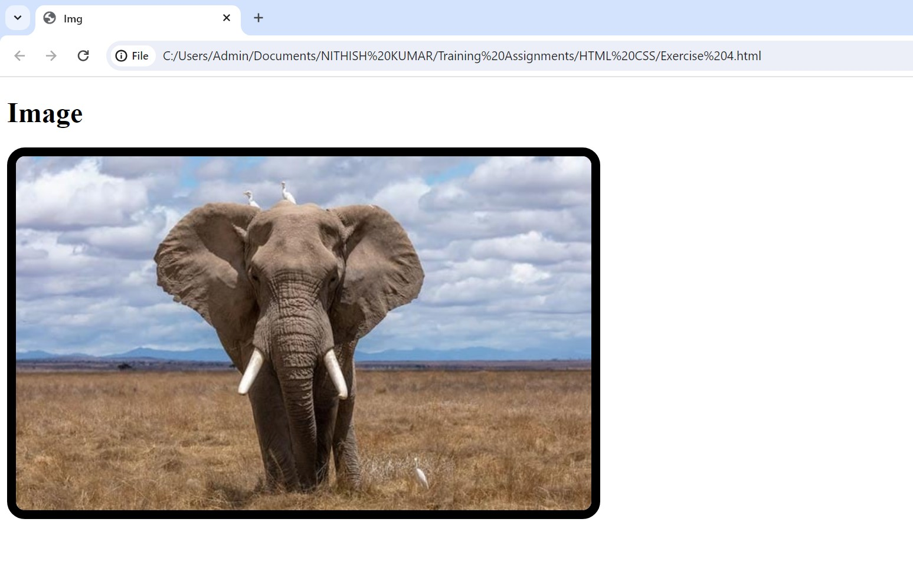

### **Exercise 5:**

HTML:

Create a two-column layout using div elements. Place some content in each column.

CSS:

Style the layout to have a fixed width, add background colors to each column, and apply some margin.

<!DOCTYPE html>

<html>

    <head>

        <title>Div</title>

        <style>

            div{

                display: inline-block;

                padding: 10px;

                width: 100px;

                margin: 30px;

            }

        </style>

    </head>

    <body style="text-align: center;" >

        <h1>Layout</h1><br>

        <div style="background-color: cadetblue;">

            <h1>Section 1</h1>

            <p>This is the first column section in division.</p>

        </div>

        <div style="background-color: hotpink;">

            <h1>Section 2</h1>

            <p>This is the second column section in division.</p>

        </div>

        <p>Two column layout with different background-color and conent.</p>

    </body>

</html>

